Land Disposition Report and Due Diligence Checklist
Common Council of the City of Milwaukee

Date
January 14, 2025

Responsible Staff
Dwayne Edwards, Department of City Development, Real Estate Staff

Parcel Addresses and Description
3809-15 West Villard Avenue (the “Property”), is a single-story, 2,680 square foot commercial building having three retail units and a lot area of approximately 6,916 square feet. The City of Milwaukee acquired the Property on October 10, 2022 through property tax foreclosure.

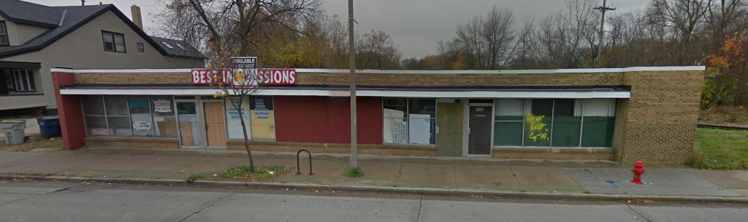
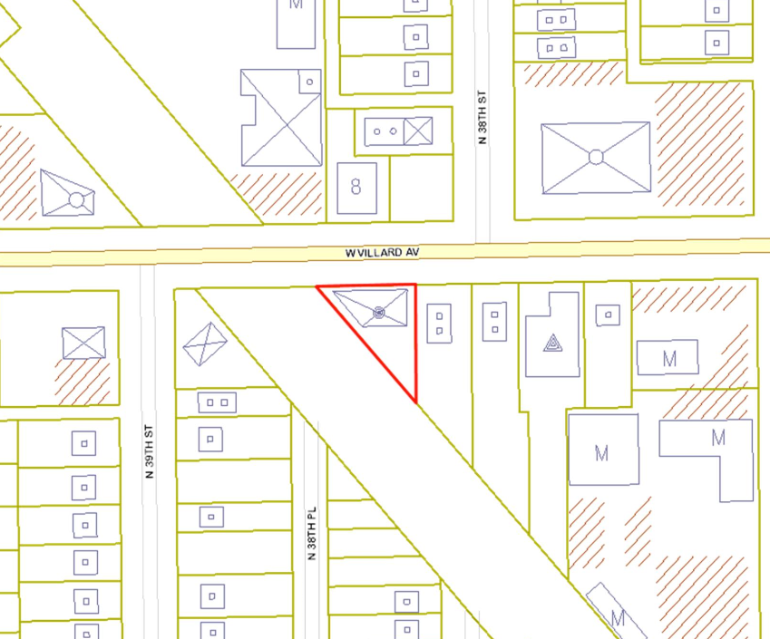
City commercial property 3809-15 West Villard Avenue (front view)

Buyer
AJ & KS LLC, (the “Buyer”) seeks to purchase and renovate the single-story City commercial building into a neighborhood fast-casual dining restaurant. The buyer, who also operates a successful restaurant at 8501 West Greenfield Avenue in West Milwaukee, plans to open a second location here in the 1st Aldermanic District, that includes signature items like specialty burgers and submarine sandwiches.
Buyer’s Conceptual rendering looking South at 3809-15 West Villard Avenue
Buyer’s conceptual rendering – east view on West Villard Avenue
Project Description
The Buyer proposes to renovate the property primarily as a neighborhood “fast-casual” food restaurant and be part of the resurgence along this portion of West Villard Avenue’s business corridor. Other recent or planned developments along the corridor include a 44-unit apartment building, a proposed multi-use performance venue at the Villard Avenue theater and new street improvements from West 35th Street to West Sherman Boulevard. The Buyer hopes to provide job opportunities for area residents and students. Mr. Ali wants to provide an attractive establishment and forge partnerships with businesses to make the area successful and attractive to all who venture through the business strip.

- The property at 3809-15 West Villard Avenue will include interior improvements for the front retail space, roof repair, new flooring, windows, plumbing and electrical upgrades. Exterior improvements will include, but not be limited to new doors, signage, painting and other outdoor façade improvements.

Total estimated rehabilitation costs are approximately $150,000, with a minor percentage of the renovations being completed through Buyer’s “sweat equity.” The project may require certain City approvals in addition to the approval of the Land Disposition Report. Closing is contingent upon the Buyer obtaining all necessary approvals, financing and Department of City Development approval of the final building exterior elevations.

Purchase Terms and Conditions
The purchase price is $38,000, which factors in the overall condition of the property. The Buyer will use personal savings and sweat equity, while also exploring available City funding resources that may be available. The Buyer shall pay to City, $2,500 to hold as a performance deposit to ensure timely completion of the project. If the project has not achieved completion on or before the completion date and obtained a Certificate of Occupancy by February 26, 2026, City shall retain the performance deposit as its own. If the project is completed by the completion date, and the Buyer obtains a Certificate of Occupancy, City shall return the performance deposit without interest to the Buyer.

The conveyance of the property will be on an “As Is, Where Is” basis. The deed of conveyance will contain a restriction prohibiting the Buyer, or its successors, from applying to the City of Milwaukee for tax-exempt property status. At closing, subtracted from the sale proceeds will be sale and marketing expenses and a 30 percent disposition cost reimbursement to the Redevelopment Authority of the City of Milwaukee, with the remaining proceeds being deposited in the City’s Tax Deficit Fund.

Due Diligence Checklist
Addresses: 3809-15 West Villard Avenue

The Commissioner’s assessment of the market value of the property. | The Property at 3809-15 West Villard Avenue is being sold “as is, where is,” without any guarantees. The building was constructed in 1957, and is zoned LB2 or Local Business. The single-story commercial building offers three retail units with a total square footage of 2,680 square feet of space on a high traffic street.  The purchase price for the property is $38,000. The property has considerable deferred maintenance, including a leaking roof and defective electrical and plumbing. The leaking roof has negatively affected the interior of the building.
Full description of the development project. | AJ & KS, LLC, (the “Buyer”) is owned and managed by Ameer Ali. The Buyer will purchase and renovate the property to operate a neighborhood fast-casual restaurant, offering burgers and submarine sandwiches.
Complete site, operations and landscaping plans and architectural renderings for new construction or redevelopment. | The Buyer was advised that any changes or modifications to the exterior facade may require approval from the City of Milwaukee Planning staff.
Developer’s development project history. | The Buyer also has a similar business at 8501 West Greenfield Avenue in West Milwaukee. The Buyer has owned and operated his current establishment since 2011.
Capital structure of the project, including sources, terms and rights for all project funding. | The estimated renovation and improvement costs are approximately $150,000. The Buyer will use personal savings and sweat equity, while also exploring available City funding resources that may be applicable.
Project cash flows for the lease term for leased property. | Not applicable.
List and description of project risk factors. | If the buildings remain vacant, the deferred maintenance and costs to cure will continue to increase. Continued vacancy of the building will serve as a hindrance on efforts to redevelop the property and this stretch of West Villard Avenue’s business corridor.
Tax consequences of the project for the City. | The property will be fully taxable. The deed of conveyance will contain a restriction prohibiting the Buyer or its successors from applying to the City for tax-exempt property status. The Buyer shall pay to City $2,500 to hold as a performance deposit to ensure timely completion of the project.

