Land Disposition Report
Common Council of the City of Milwaukee

Date
January 14, 2025

Responsible Staff
Dwayne Edwards, Department of City Development (“DCD”), Real Estate

Parcel Address & Description
5229 North 51st Boulevard: An existing church and parsonage on a 42,233 square foot lot, acquired by the City of Milwaukee (“City”) through tax foreclosure on December 2, 2013. The property is in the McGovern Park neighborhood, in the 1st Aldermanic District.

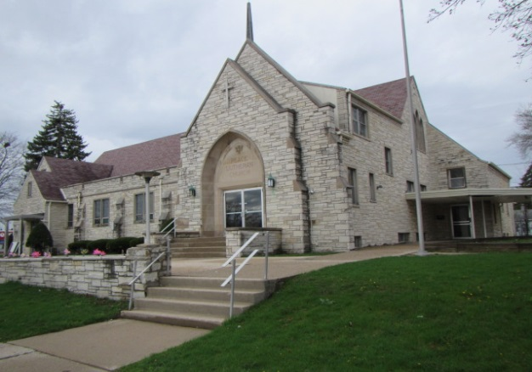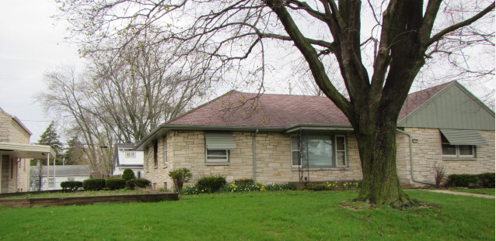

City Church and Parsonage

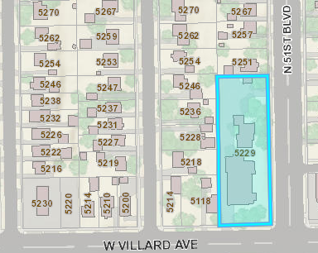

Map Identifying City Property
Buyer/ Project Description
Lord’s Way International was established in 2018 and seeks to provide religious activities and worship services to its congregation of 60 members. The Buyers also plan to offer outreach activities and programs to area residents through various partnerships with community-based organizations that provide services for help, transformation and assistance to those we serve in the community. Some of those partnerships may include the following, but are not limited to:

- Project RETURN, Hope Street Ministries and others
- Medical College of Wisconsin
- Ascension All Saints Family Health Center

Lord’s Way International (“LWI”), managed by Pastor James Boyd Sr., will use the property for religious services for worship, provide weekly services to include life classes, bible study classes, AODA counseling, Family counseling, Marriage counseling and empowerment classes among other activities to help men, women and children with various self-esteem, behavioral issues and relationship building issues and solutions.

The Buyer’s mission is to transform lives, impact communities and empower people.

The Buyer will also renovate the parsonage to reside on-site.

Needed renovations to the church and parsonage will be approximately $300,000. Interior improvements include, but are not limited to replacing the church’s boiler system and installing new forced air furnaces in both properties. Exterior work will include new roof and awnings for both church and parsonage, extensive landscaping, installing digital display boards and power washing exterior surfaces on both properties.

Purchase Terms and Conditions
The purchase price will be $100,000 and Buyer shall pay all closing costs. The conveyance will be on an “As Is, Where Is” basis. The Buyer shall pay to City $5,000 to hold as a performance deposit to ensure timely completion of the project. If the project has not achieved complete renovation and obtained a Certificate of Occupancy, by August 28, 2026, City shall retain the performance deposit as its own. If the Project has achieved completion, the City shall return the performance deposit without interest to the Buyer.

Buyer will be required to meet the City’s General Buyer Policies. The Buyer will execute a City Purchase and Sale Agreement, which will outline all terms of the transaction. The deed of conveyance will not contain a restriction prohibiting the Buyer or its successors from applying to the City for tax-exempt property status pursuant to MCO 304-49-13(b). At Closing, subtracted from the sale proceeds will be sale and marketing expenses and a 30 percent disposition cost reimbursement to the Redevelopment Authority of the City of Milwaukee, with the remaining proceeds being deposited in the City’s Tax Deficit Fund.

